Exercise / Homework for Lecture 8

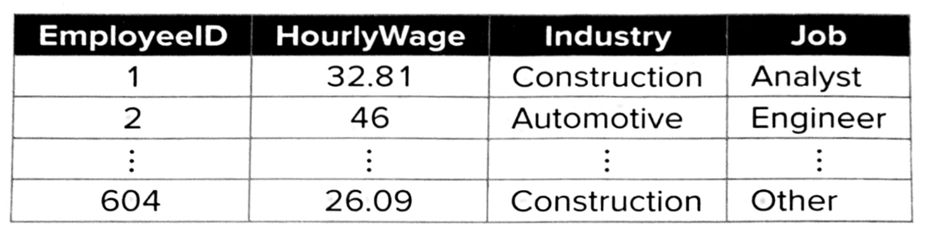

The manager suspects that data about the gig employees are sometimes incomplete, perhaps due to the short engagement and the transient nature of the employees.

She would like to find the number of missing observations for the HourlyWage, Industry, and Job variables.

In addition, she would like information on the number of employees who:
(1) worked in the automotive industry,
(2) earned more than $30 per hour, and
(3) worked in the automotive industry and earned more than $30 per hour.
(4) the manager would like to know the hourly wage of the lowest-and the highest-paid employees at the company as a whole and the hourly wage of the lowest- and the highest-paid accountants who worked in the automotive and the tech industries.
(5) transform the HourlyWage into 3 equal-width bins with categorical labels of Low, Medium, and High. Subsetting the data in to these 3 groups.

